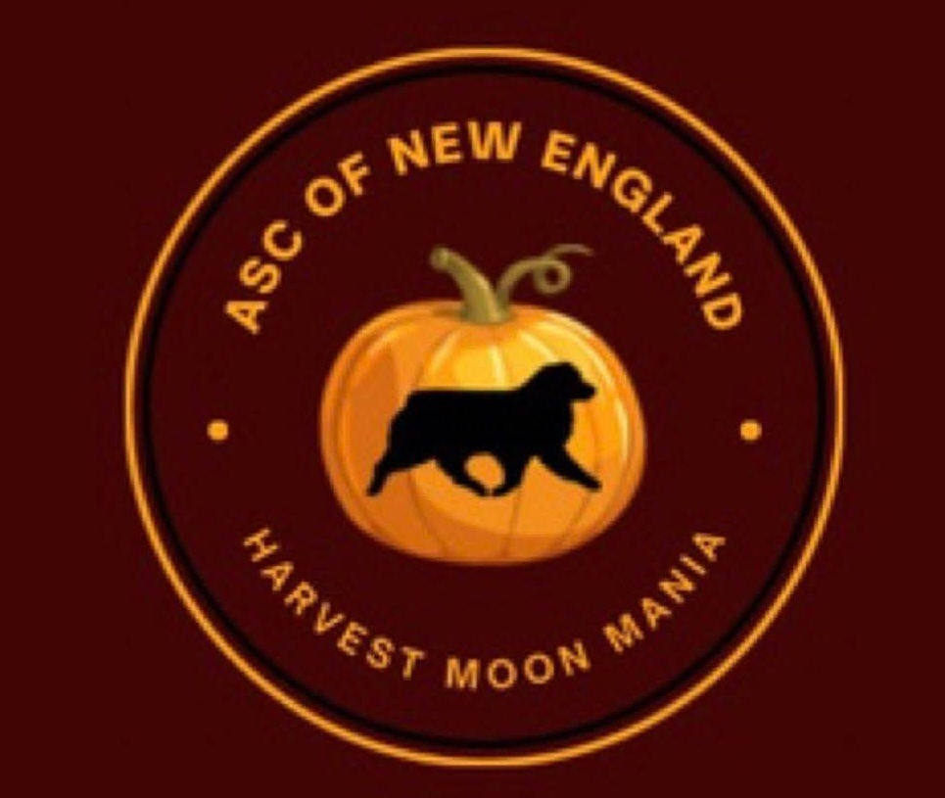

ASCNE Harvest Moon Mania
Stockdog Trial
(ASCA Sanctioning Pending)

Date: Saturday October 17 & Sunday October 18 , 2026
Location: Starshine Farm 33 Oliver Rd Lebanon CT

Start Time: Cattle – Handler’s Meeting 8am
Runs will begin at end of handler’s meeting
Sheep & Duck handler’s meeting will start after cattle runs are finished.

Judge: Maxine Schvaneveldt ID

Course Director: Barbara Barreiro Trial Chair: Barbara Barreiro

Courses: Saturday – ASCA Course B for cattle and sheep Course F for ducks Sunday – ASCA Course A for all livestock
Classes: Advanced, Open, Started, Junior, Junior with adult, FEO

Livestock: Cattle – 3 Head of Dexter or Dexter Crosses
(9-16 runs/day) $75/run
Sheep – 3-5 Head of Katahdin
(15-20 runs/day) $60/run
Ducks – 5 Head of Calls or Appleyards
(15-20 runs/day) $50/run

Pre-entries will be accepted with the post mark dates between:
September 8 through October 5, 2026
Entries accepted after October 5 will increase by $10/run
Link for ASCA Stock Entry Form: https://asca.org/wpcontent/uploads/2016/04/stockdogentyform.pdf
THIS ENTRY MUST BE USED. PLEASE DO NOT USE OLDER VERSIONS

PayPal is now available as a form of payment for ASCNE entries. Please read below for instructions on how to use this:

Payment can be made by sending in a check with your entries to the trial secretary listed on the Premium or via PayPal at ascnetreasurer1973@gmail.com (please DO NOT send as “Friends and Family”). Please
include an additional 3% with any PayPal payments along with the owner / exhibitor’s name and the show AND venue you are entering. A separate transaction must be made if you are entering multiple venues (ex: 1
transaction for conformation, 1 transaction for agility, etc). Entries are not valid until full payment is made, including the additional 3%. Day of show entries must be paid by either check or cash.

Link for Tracking Form for non ASCA registered competitors: https://asca.org/wpcontent/uploads/2022/06/qtsvcapp.pdf

Entries will be accepted in post mark order. In case of a duplicate postmark entry, a random draw will be held for those entries, for each specific livestock, to determine
order of acceptance. Day of show entries will be allowed if space is available. A waiting list will be established if the trial fills. After the close of entries, entry fees will only be refunded if your spot can be filled from the waiting list.
Run Order will be drawn prior to the trial day.

Checks should be made out to ASCNE and mailed to:
Barbara Barreiro, 258 Forest St Sanbornville NH 03872
Please make sure to include your email address on the entry form so confirmation can be sent if your entry was accepted or if you are on the waiting list.
US FUNDS ONLY, NO FOREIGN CURRENCY EXCEPTED

All trials will be run according to the ASCA Stockdog Rules which can be reviewed at ASCA.ORG Bitches in heat will run in order and must be crated at all other times.

Injured livestock expense is the financial responsibility of the dog’s owner/handler.
Replacement costs for livestock are as follows:
Cattle $1200, Sheep $500, Duck $50

Awards will be presented for 1st – 4th placements in each class of livestock in each division.
HIT Australian Shepherd and HIT Other Breed will be awarded each day.

High Combined Started Dog for the Weekend will be awarded to the Started level dog with the highest
combined Started Qualifying scores from Saturday and Sunday

Qualifying ribbons and Title Ribbons will also be available.

Hotels in the area:
Sleep Inn Willington CT 860 684 1400
Howard Johnson Lodge Vernon CT 860 875 0781
Red Roof Inn New London CT 860 444 0001
Motel 6Vernon CT 860 646 5700
Waters Edge Family Campground (RV and cabins)860 642 7470

Emergency Vet Information:
Animal Emergency Hospital of Central CT 860 563 1027 588 Cromwell Ave Rocky Hill CT 06067

